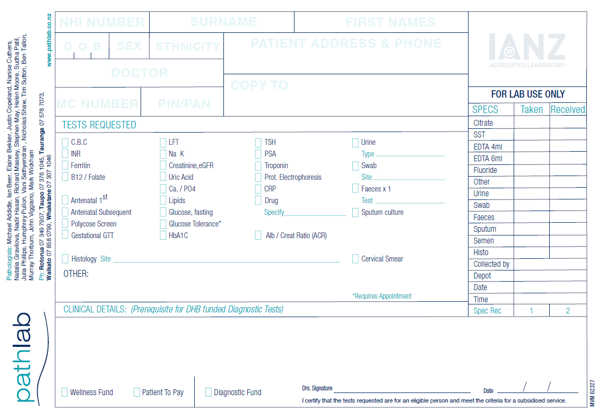

**Supporting Clinical Information:**

**SYMPTONS: TRAVEL:** Yes / No Days since return ____

Date of onset _________________

Fever: Yes / No **CONTACT** with COVID patient: Yes / No

Cough: Yes / No

SOB: Yes / No **HEALTHCARE WORKER:** Yes / No

Sore Throat: Yes / No

Other Symptoms:

SWAB for COVID-19 TESTING

Swab type:

Nasopharyngeal

Oropharyngeal

*24.5.20 Version 2.4 Community*