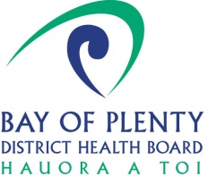

Personal Protective Equipment (PPE) Order Form
Community Care Providers

Requestor Details:
Organisation Name:
Contact Name:
Contact Cellphone:
Delivery Address:

PPE Request Details: Please allow 36 hours from order to delivery – excluding weekends and public holidays
Please try to source PPE from your normal suppliers before requesting
DHB Code | Description | Standard Qty | Qty Required
253766 | Masks – surgical (patients/staff) | BX 50
301325 | Masks – surgical (staff) | BX 50
289627 | Masks – N95 | BX 50
Goggles/Visors: Please ensure you are washing and recycling current goggles and visors
261964 | Goggles | EACH
257739 | Visor | EACH
255742 | Gowns (isolation) extra large | BX 10
264441 | Apron Disposable | EACH
Hand Gel: Please ensure that wherever possible soap and hot water is used
262810 | Alcohol Hand Gel – 500ml | EACH
Wipes: To be used to clean all clinical equipment only. Disinfectant solution should be used to clean down any other areas
285997 | Disinfectant wipes | Pack 50
267285 | Gloves Small | BX 200
267286 | Gloves Medium | BX 200
267287 | Gloves Large | BX 200
301502 | Covid Nasal Swab Kit | EACH

Name |  | Signature |  | Date

Please e mail this completed form to ppeordering@bopdhb.govt.nz

For DHB use only:

EOC Approved:
Name |  | Signature |  | Date

Oracle Entry Completed by:
Name |  | Req # |  | Date | ____________

